New Ion Pump Controller and Rim Box Monitor
New Rim box to Pax Case Cable
200-05-07

Photos below show current Feed with Ion Pump Control.

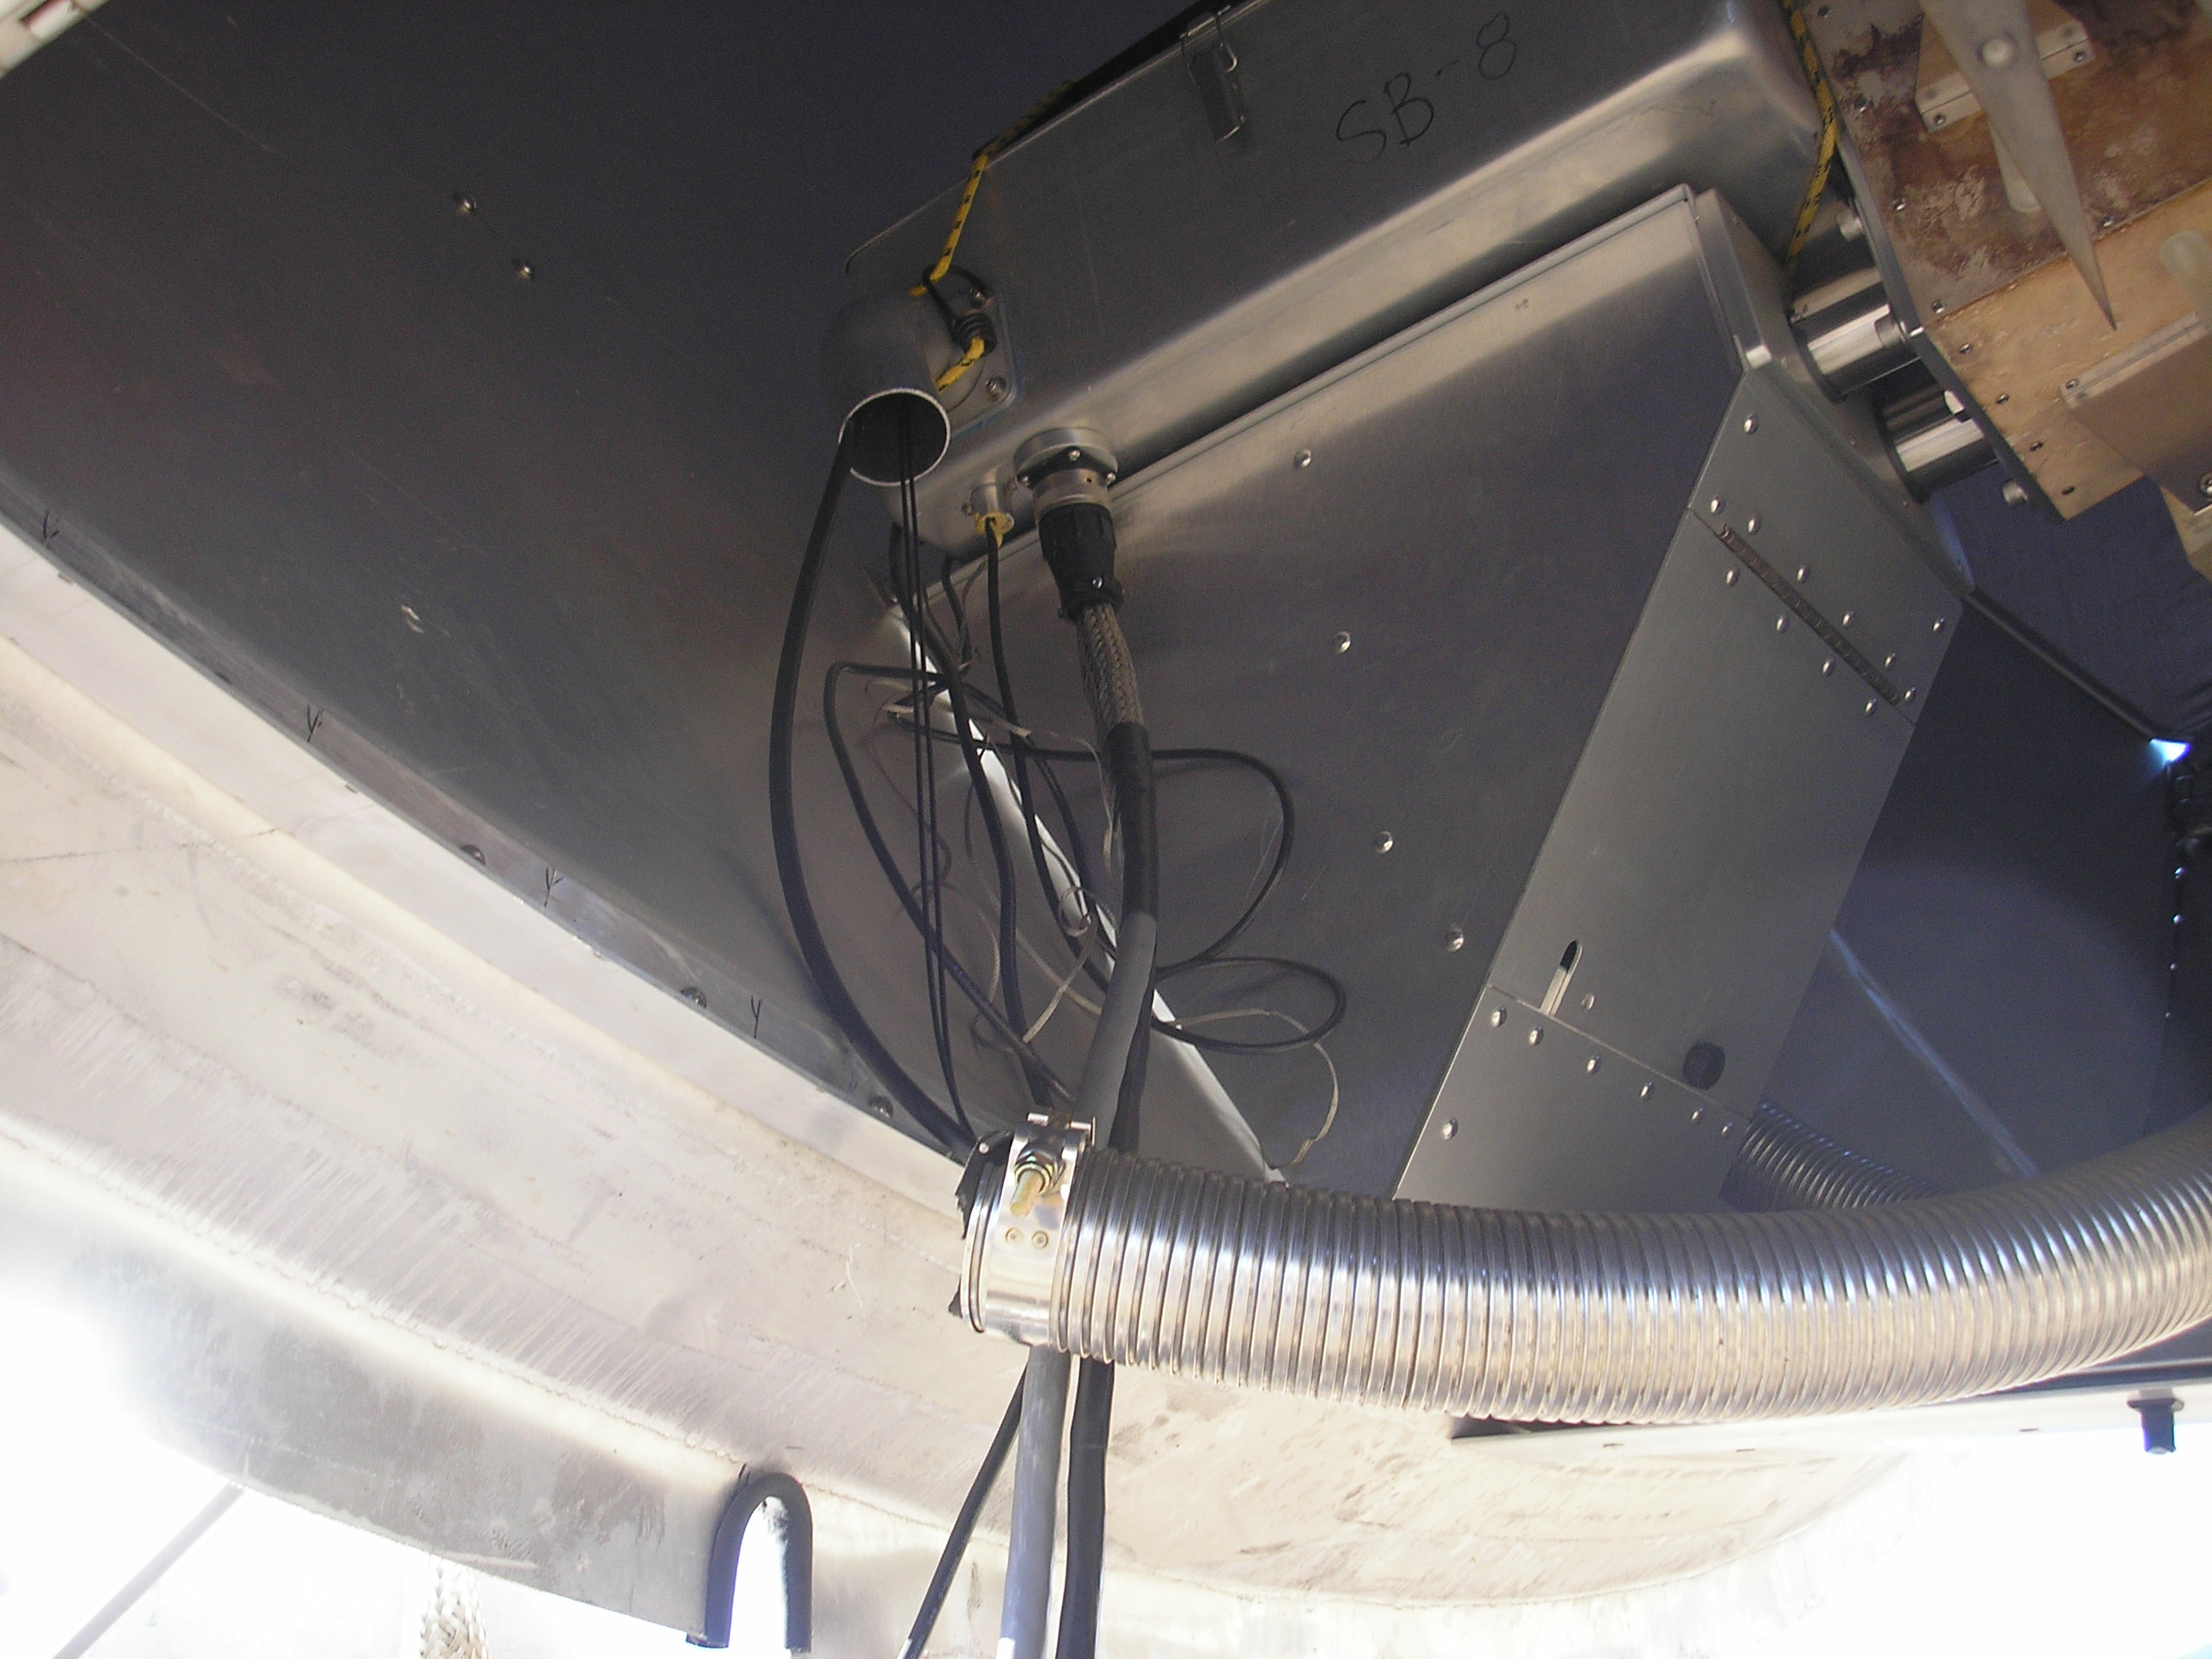
1

Controller ( high voltage supply ) is bungee corded to top of Pax Case Lid. High voltage coax cable (1/4 dia ) comes through hole in Pax Case.

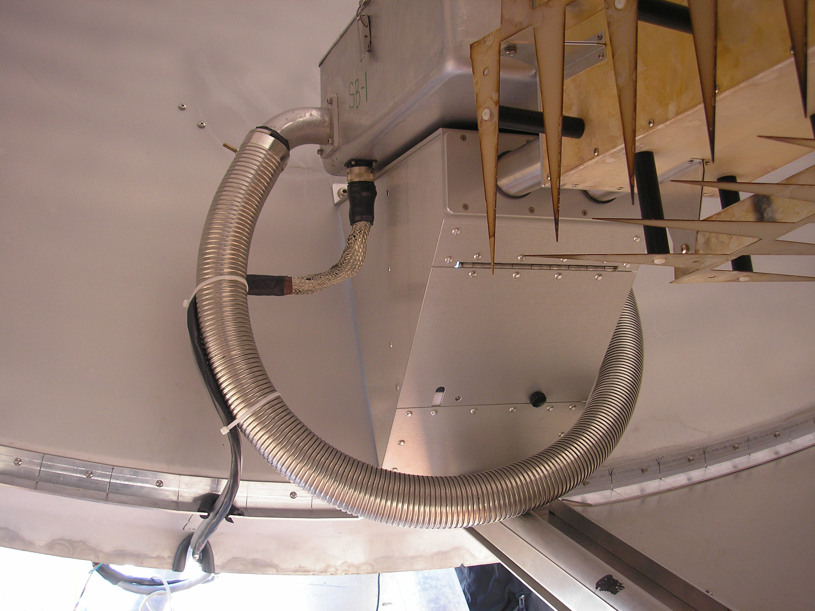
2

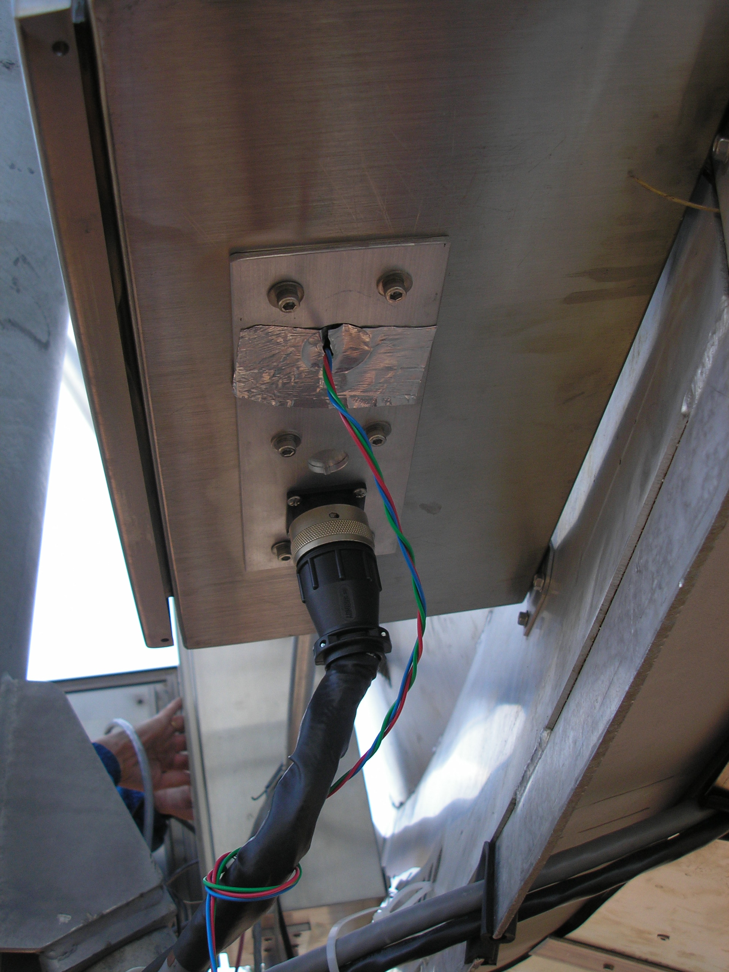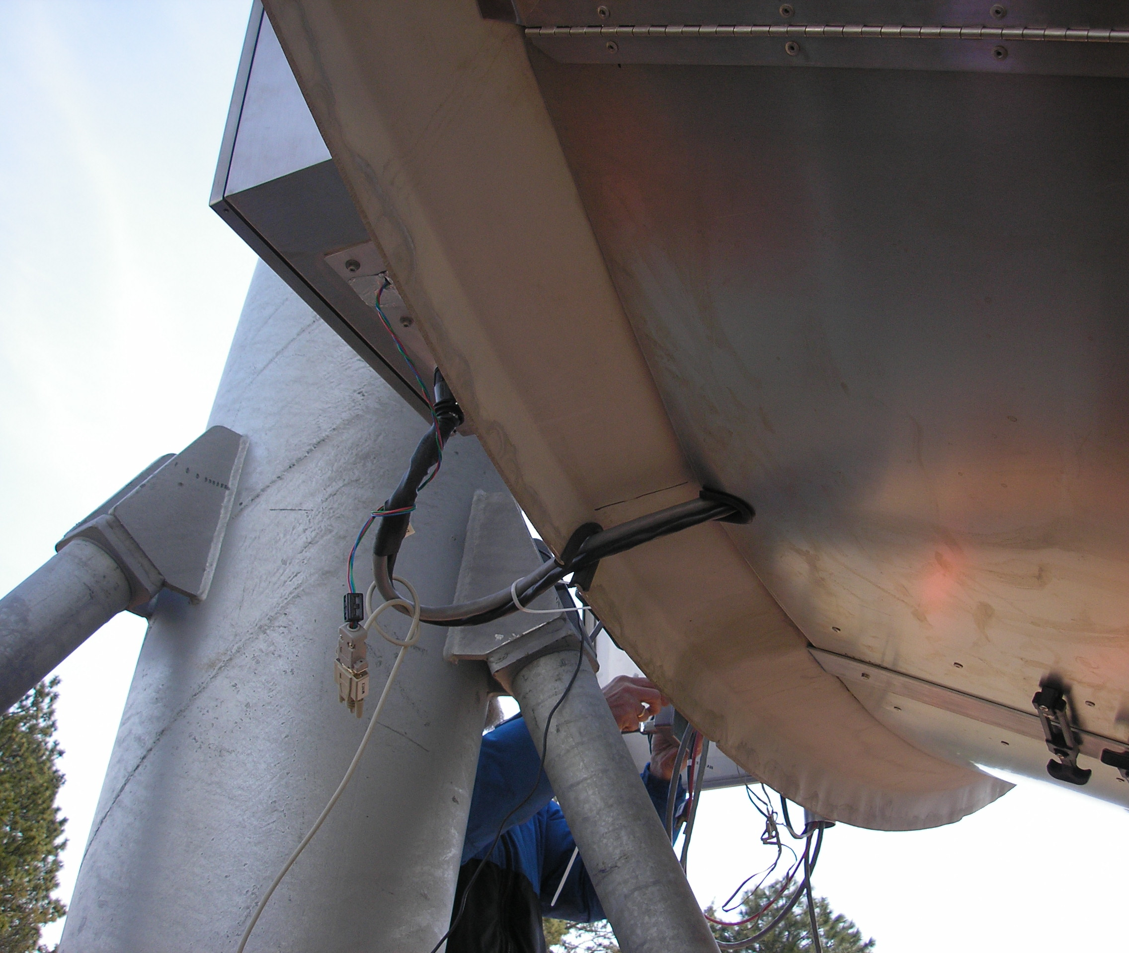
3
4

Below: Internal wiring of older rim box shown. Note bulkhead connector with many wires distributed to locations throughout the box. Also not Power terminal block and position of TEC Control Board.

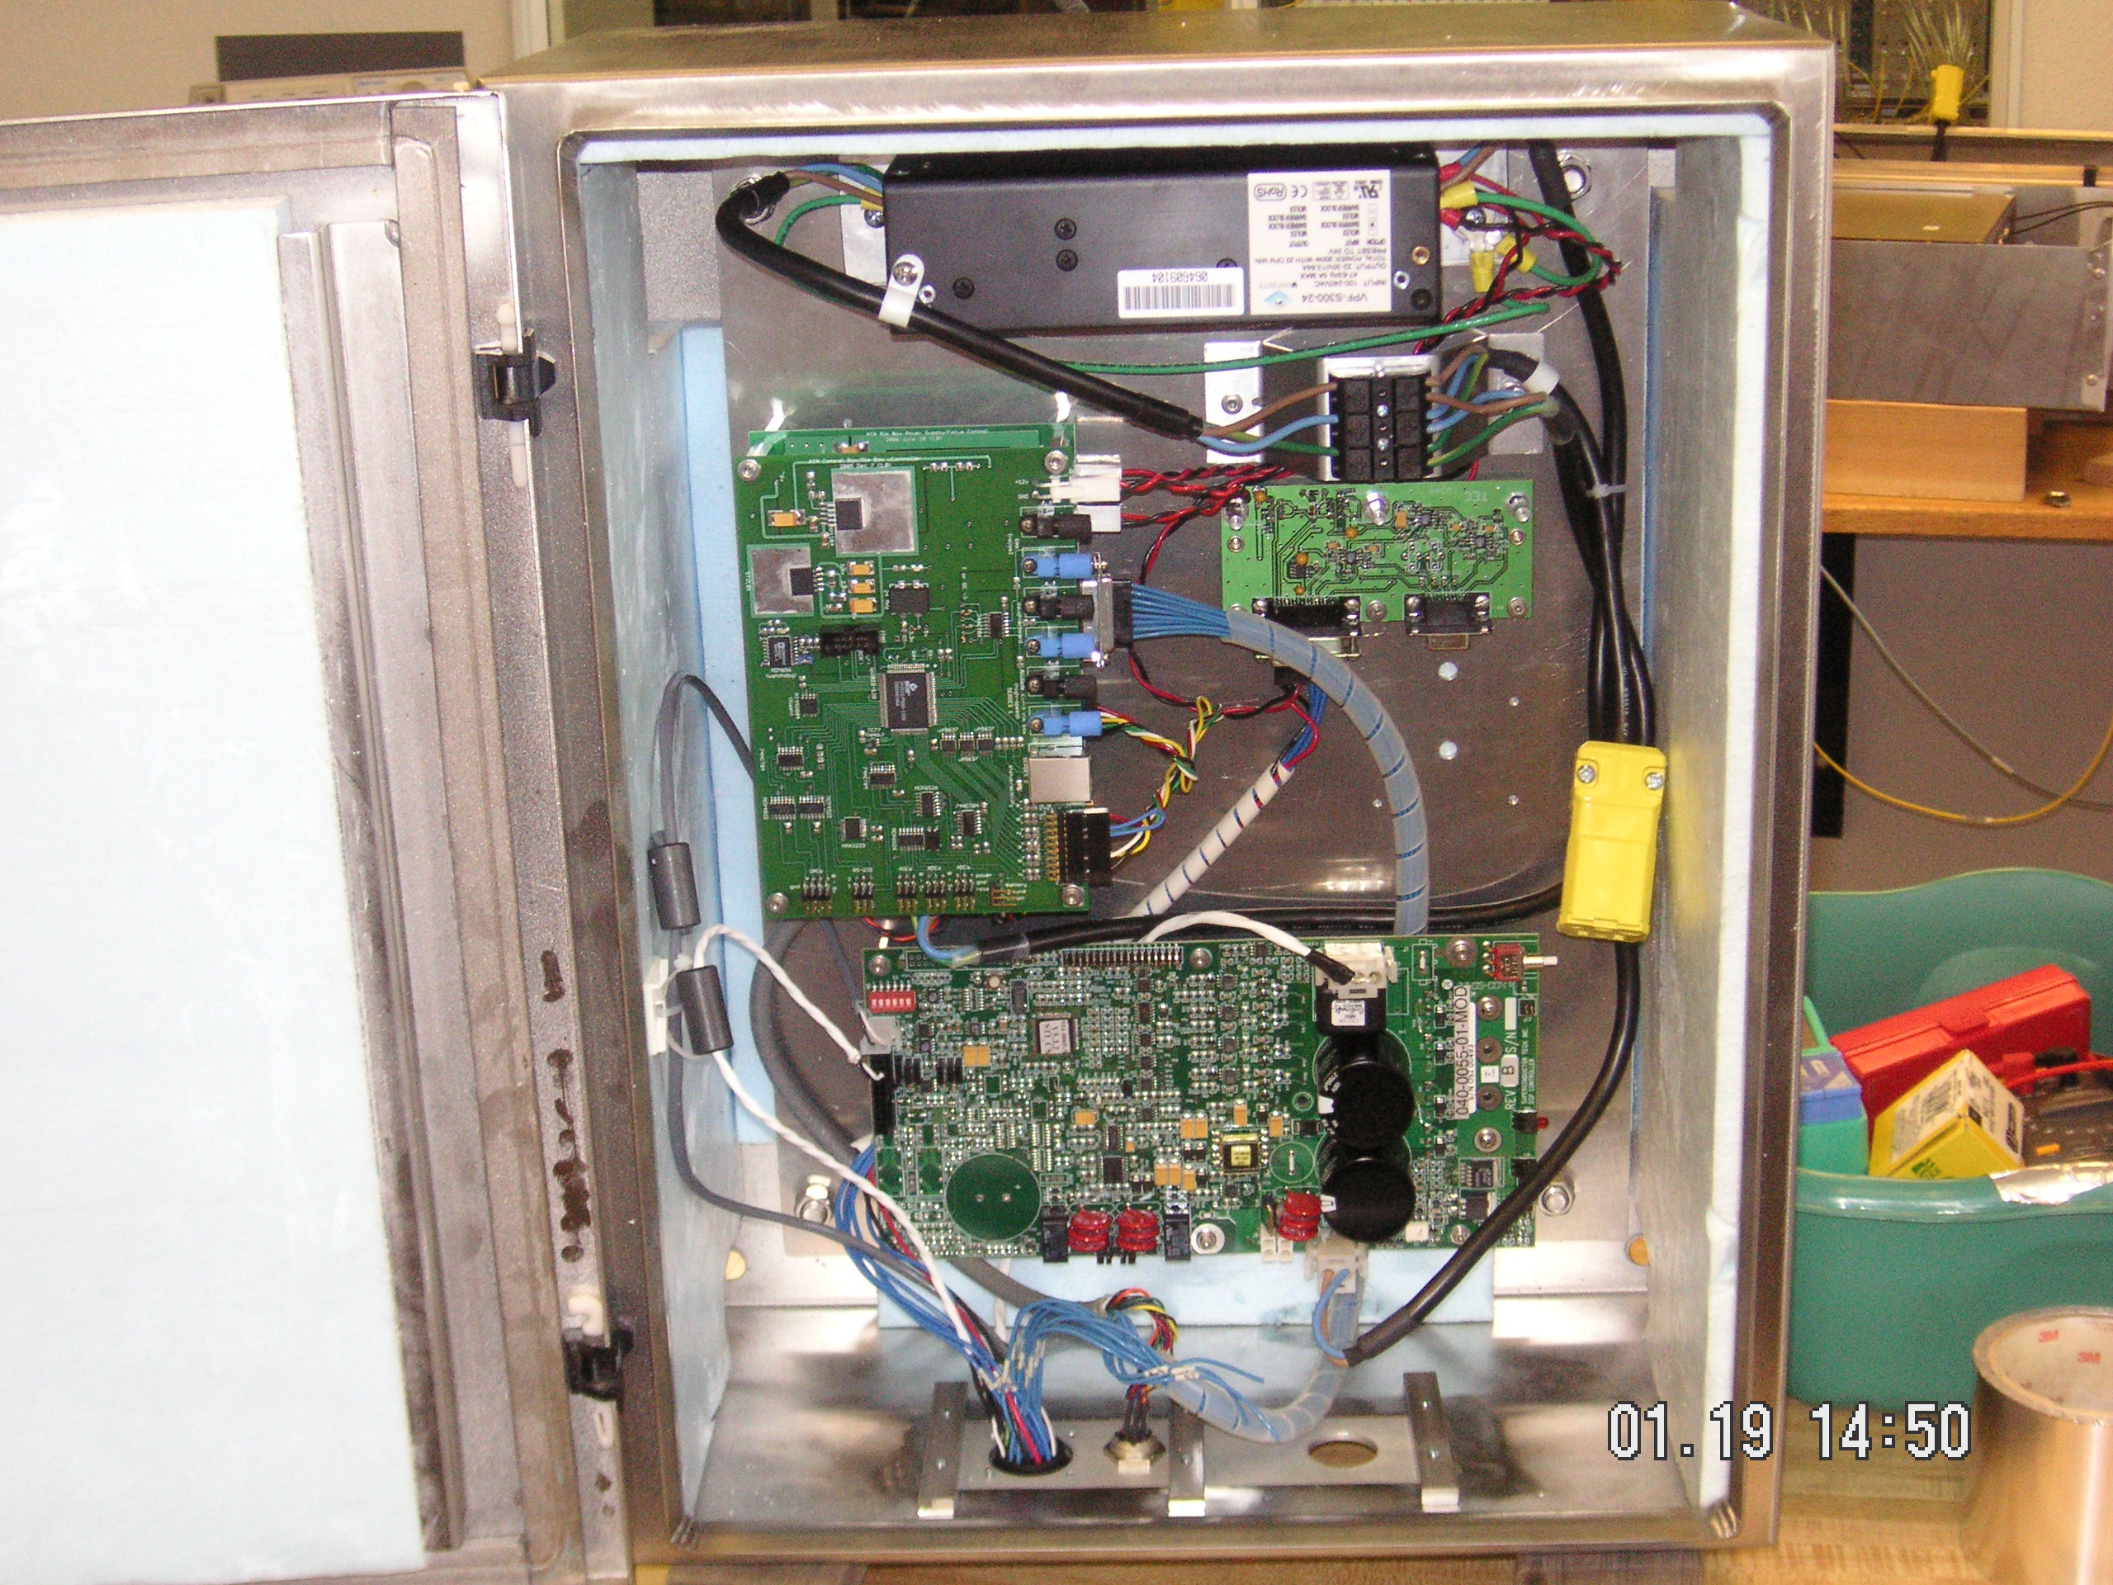
5

New Ion Pump Controller positioned inside the Pax Case.

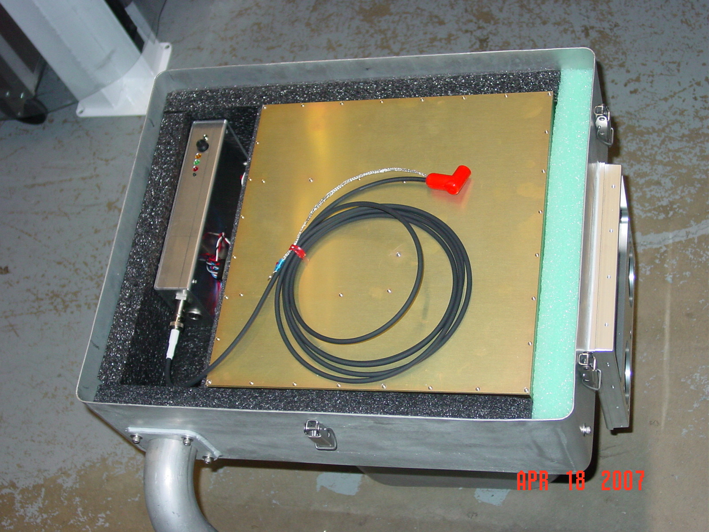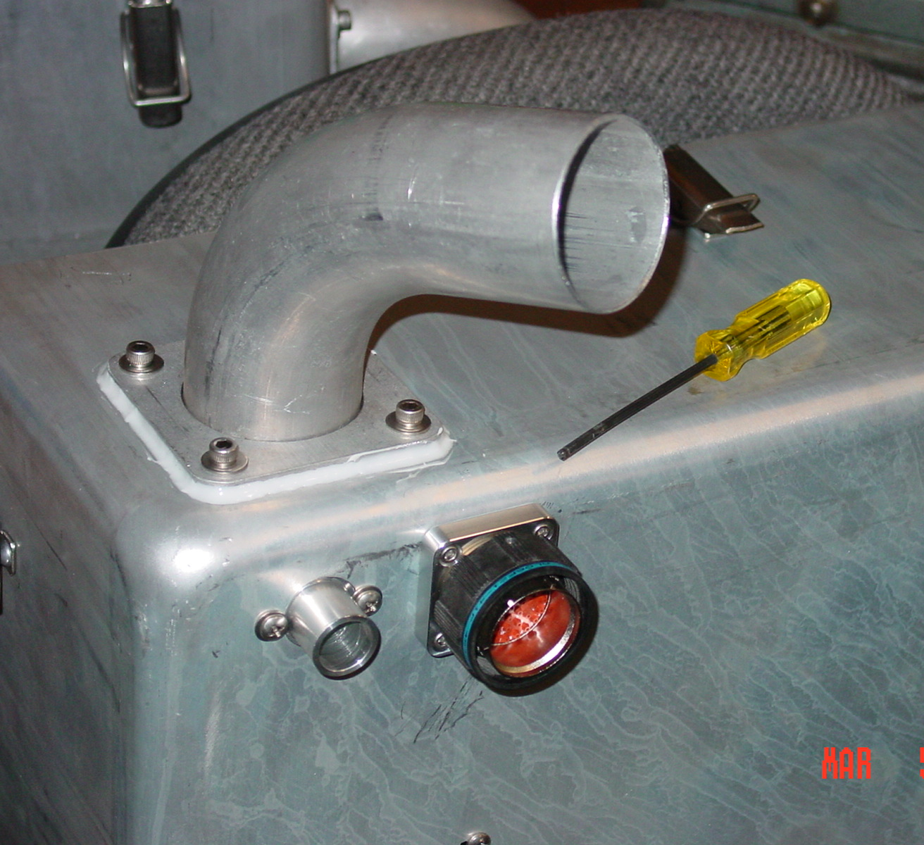
6
7

New Ion Pump Controller with input & output shown. New Monitor Board.

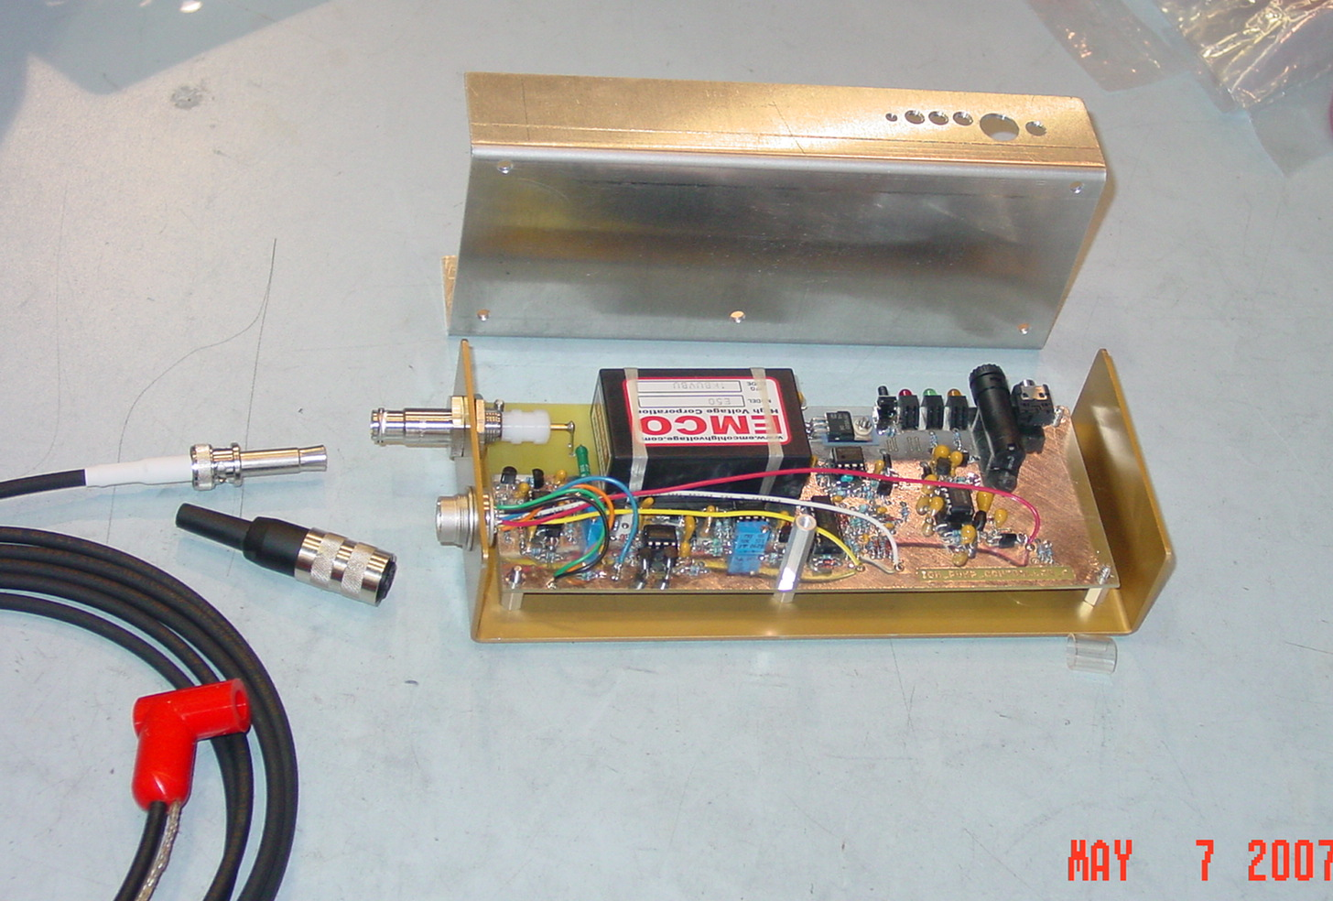
8
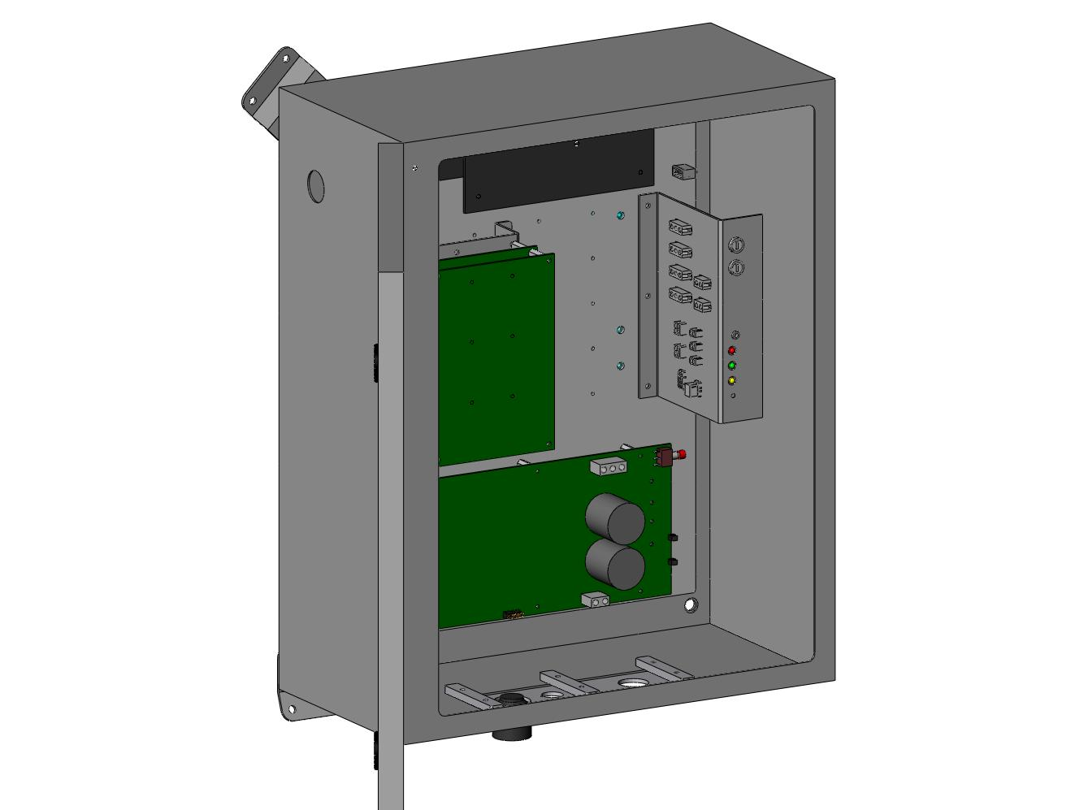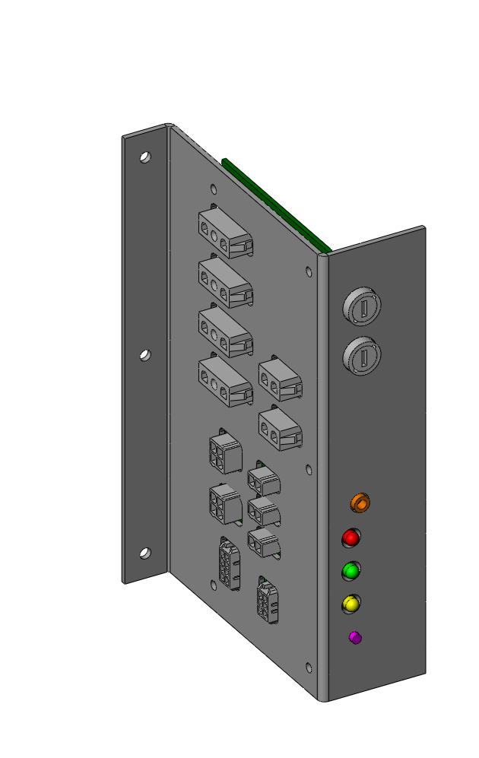
9
10

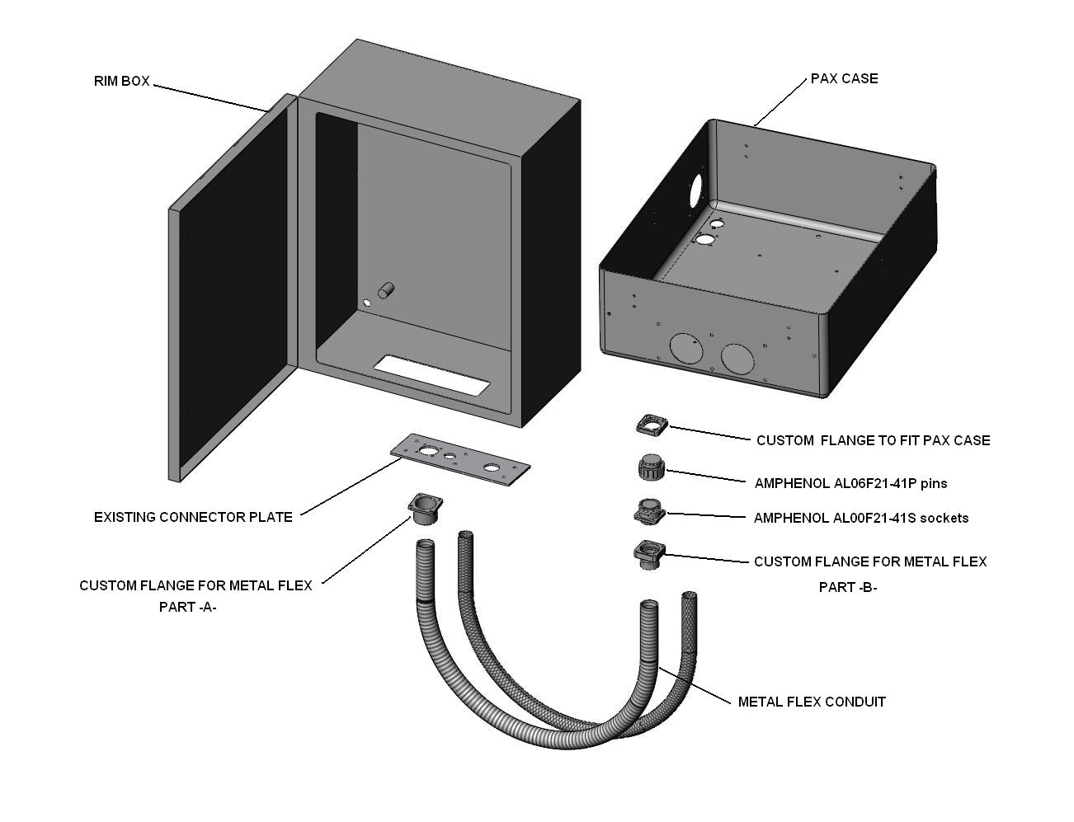
11

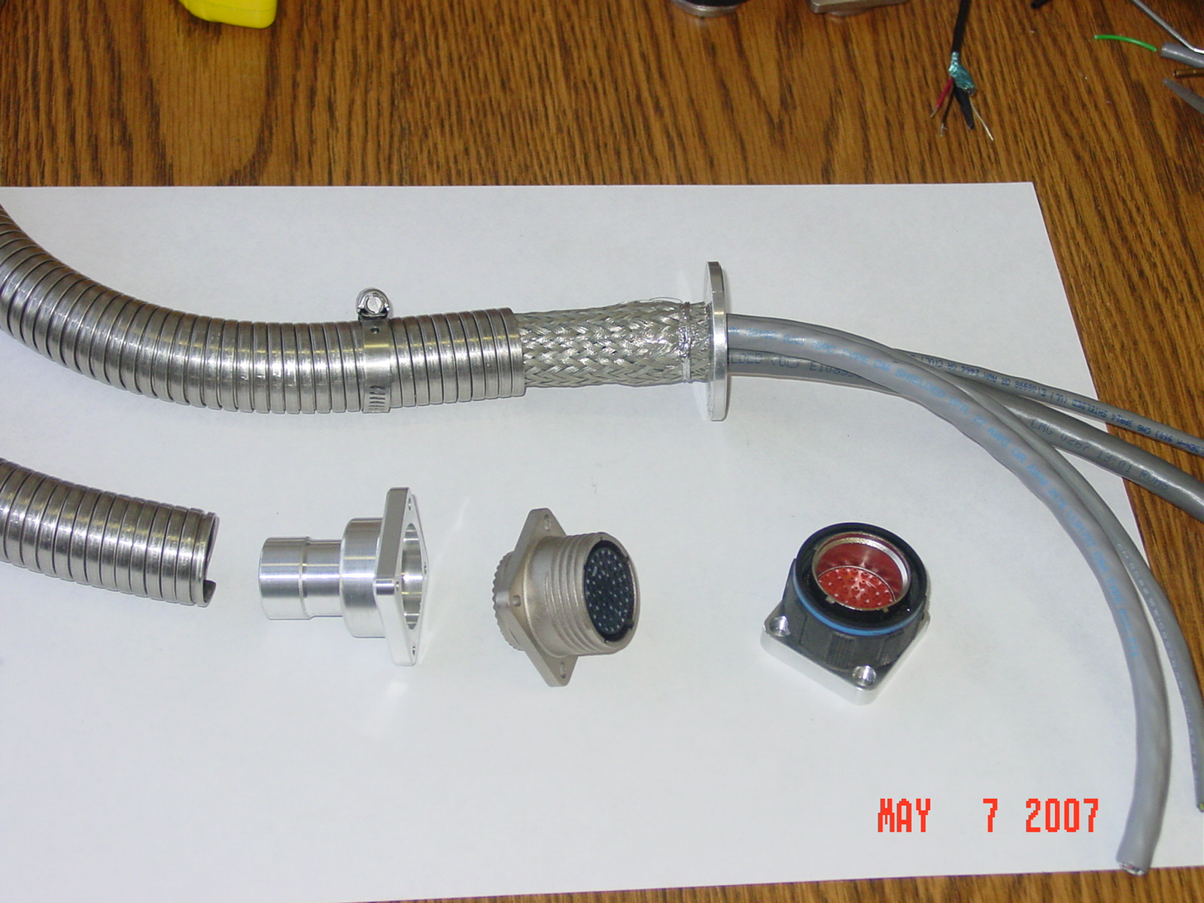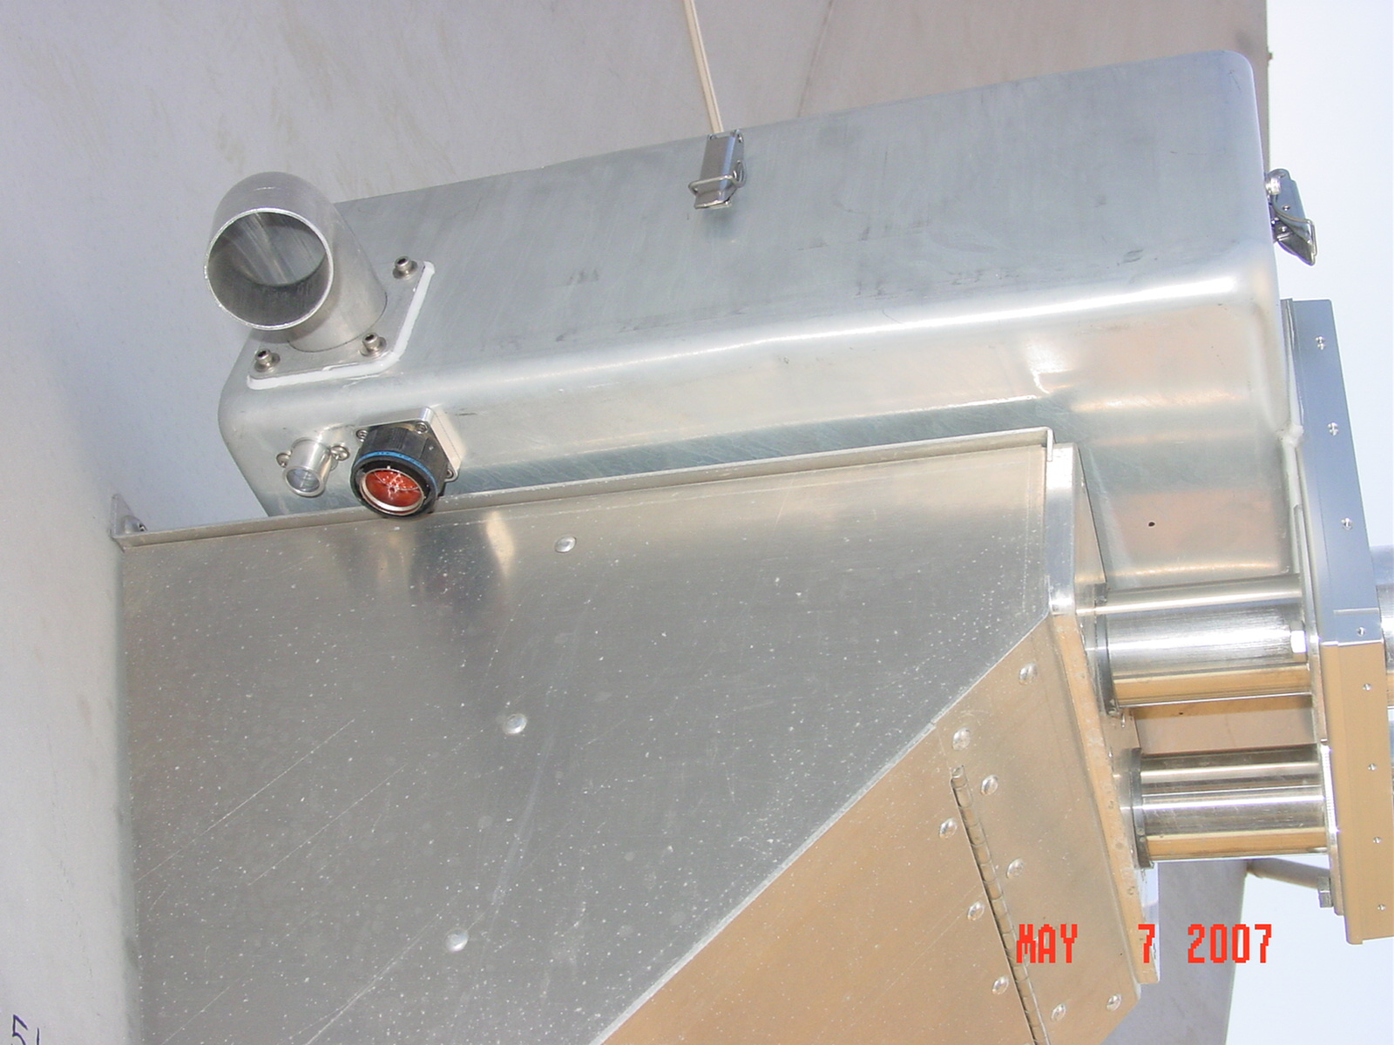
13
12

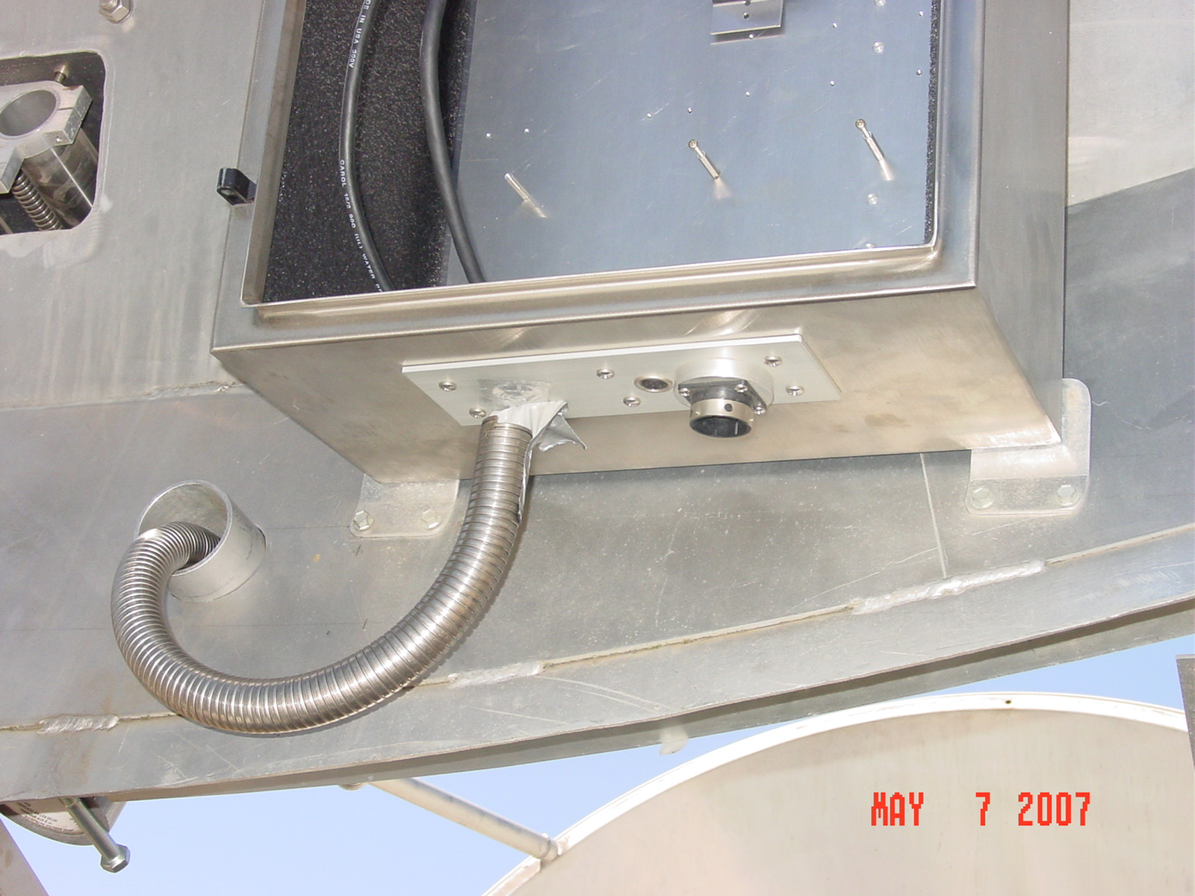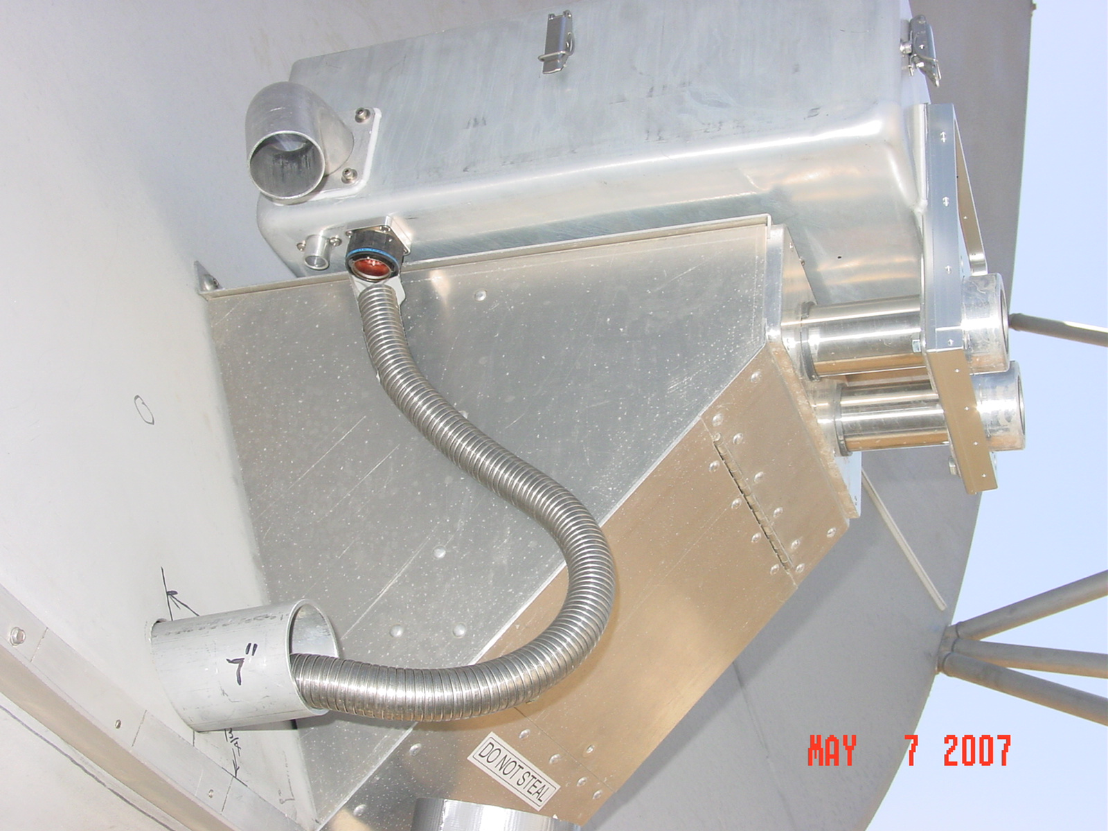
14
15

Required modification to primary for cable path. ( more instructions available )

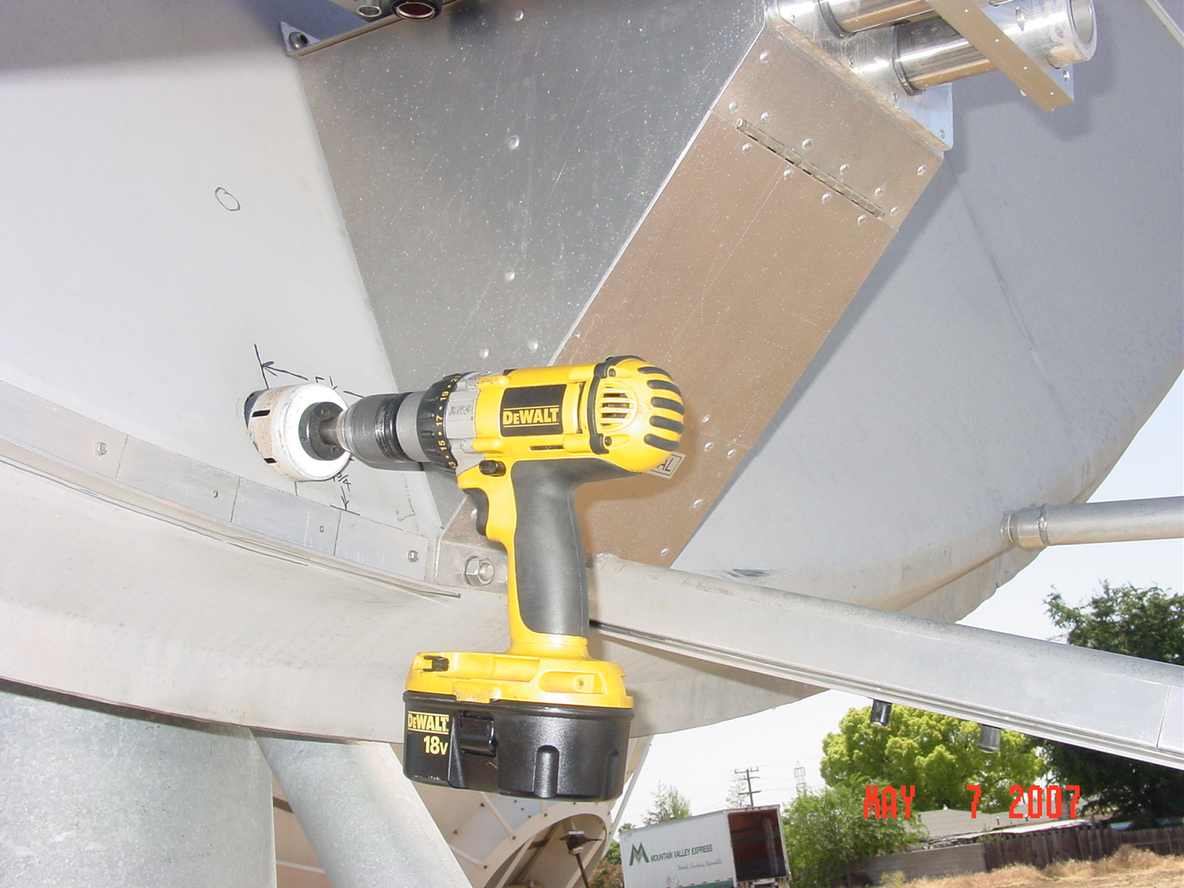
16

